**Week 4**

**-Tanisha Gotadke**

**1BM21CS229**

Query 4

Find the names of all branches that have greater assets than all branches located in Bangalore.

**select branch_name from branch where assets>(select sum(assets) from branch where branch_city='Bangalore');**

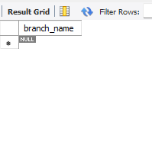

Query 5

Demonstrate how you delete all account tuples at every branch located in a specific city (Ex. Bombay).

**delete from bankaccount where branch_name in (select branch_name from branch where branch_city='Mumbai');**

**select * from BankAccount;**

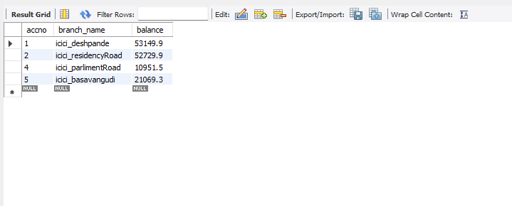

Query 6

Update the Balance of all accounts by 5%

**update BankAccount set balance = balance*1.05;**

**select * from BankAccount**

